**Knowledge Organiser EYFS Term 4 Topic: Eggs** 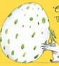

Investigating and learning about eggs will give children the opportunity for hands-on exploration, making links to living things, nutrition, and the Easter story

**Key Knowledge and Skills**

Know where eggs come from

Name the different parts of a hen’s egg

Explain what happens when eggs are boiled

Investigate how to protect a raw or boiled egg

Investigate the strength of egg shell

**Vocabulary**

Shell

Yolk

White

Investigate

Protect

Boil

Raw

Liquid

Solid

**Links to future learning**

KS1 Animal offspring, uses of everyday materials, physical properties, habitats

LKS2 Animals and habitats, states of matter

UKS2 Properties and changes in materials

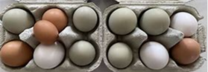

**Books**

The Hungry Caterpillar

The Emperor’s Egg

The Odd Egg

An Egg Is Quiet

Non-Fiction bird books

