
History: Local History Study: Tattershall Castle
Key questions:  - Do I know about different types of medieval castle?  - Do I know about the origins and type of castle Tattershall castle is?  - Can I talk about the roles of people in a castle during the Tudor period?  - Do I know strategies used to attack the castle and what happened to it in the civil war?  - Do I know how Tattershall castle became the castle it is today? |  |  | Key Vocabulary: Tattershall Castle, Motte-and-Bailey castle, motte, keep, bailey, palisade, stone keep castle, defence, turrets, moat, drawbridge, concentric castle, great hall, kitchen, gatehouse, chapel, curtain wall, Great Tower, stables, Guardhouse, servant, gong-farmer, cesspit, weapons, attack, ladders, fire, battering ram, catapult, mining, siege,
Key Knowledge:
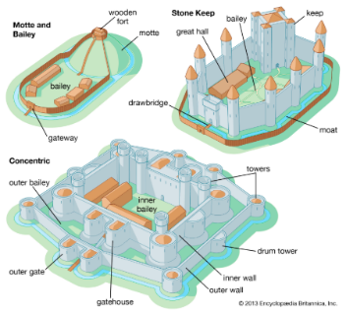
1231- Crenelated manor house built at Tattershall. It was a stone keep castle.
1433- Great tower, kitchen, stables and guardhouse were added.
1643- Castle was damaged in the civil war
1693- the castle became derelict
1911- Lord Curzon bought the castle and restored the castle, opening it as a visitor attarction.
1925-It was given to the National Trust.
Roles at the castle
Servants in the kitchen, cleaning, lighting fires, fetching and carrying wood
Gong farmer- to clean out the toilet (cesspit)
Strategies and weapons for attacking the castle
- Ladders - The enemy would try to climb over castle walls, using ladders.
- Fire - Early castles were made of wood, so they were easy to attack by setting fire to them.
- Battering ram - A large log that was hit against the castle walls to weaken them.
-Catapult - Catapults, or trebuchets, threw large stones and burning objects at the castle.
- Mining - The enemy would mine tunnels under the castle walls and then use gunpowder to create explosions, causing the walls above to crumble.
- Siege - The enemy would surround the castle, stopping those inside from being able to leave or receive food and supplies from outside.
Year 1 sentence stems:  In the past…  Now…  I know… | Working historically  This term we are working as historians by:  -Using pictures and artefacts to find out about the past  -Describing the differences between then and now | Year 2 sentence stems:  I know… because  It has changed because…

