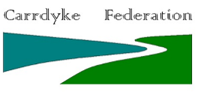
Geography: The Local area
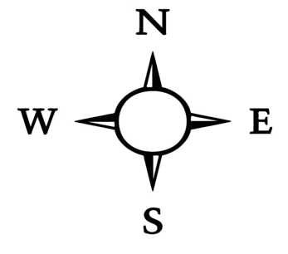  Key questions:  - Do I know that we live in the United Kingdom and the countries it is made up of?  - Can I find the Isle of Coll?  - Can I identify the features of Martin?  - Can I talk about the human and physical features of Struay?  - Can I use simple compass directions? |  |  | Key Vocabulary:  United Kingdom  England  Scotland  Wales  Northern Ireland  Struay  beach  cliff  coast  wood  mountain  village  house  shop  school  symbol  map  aerial  photograph
Key Knowledge:
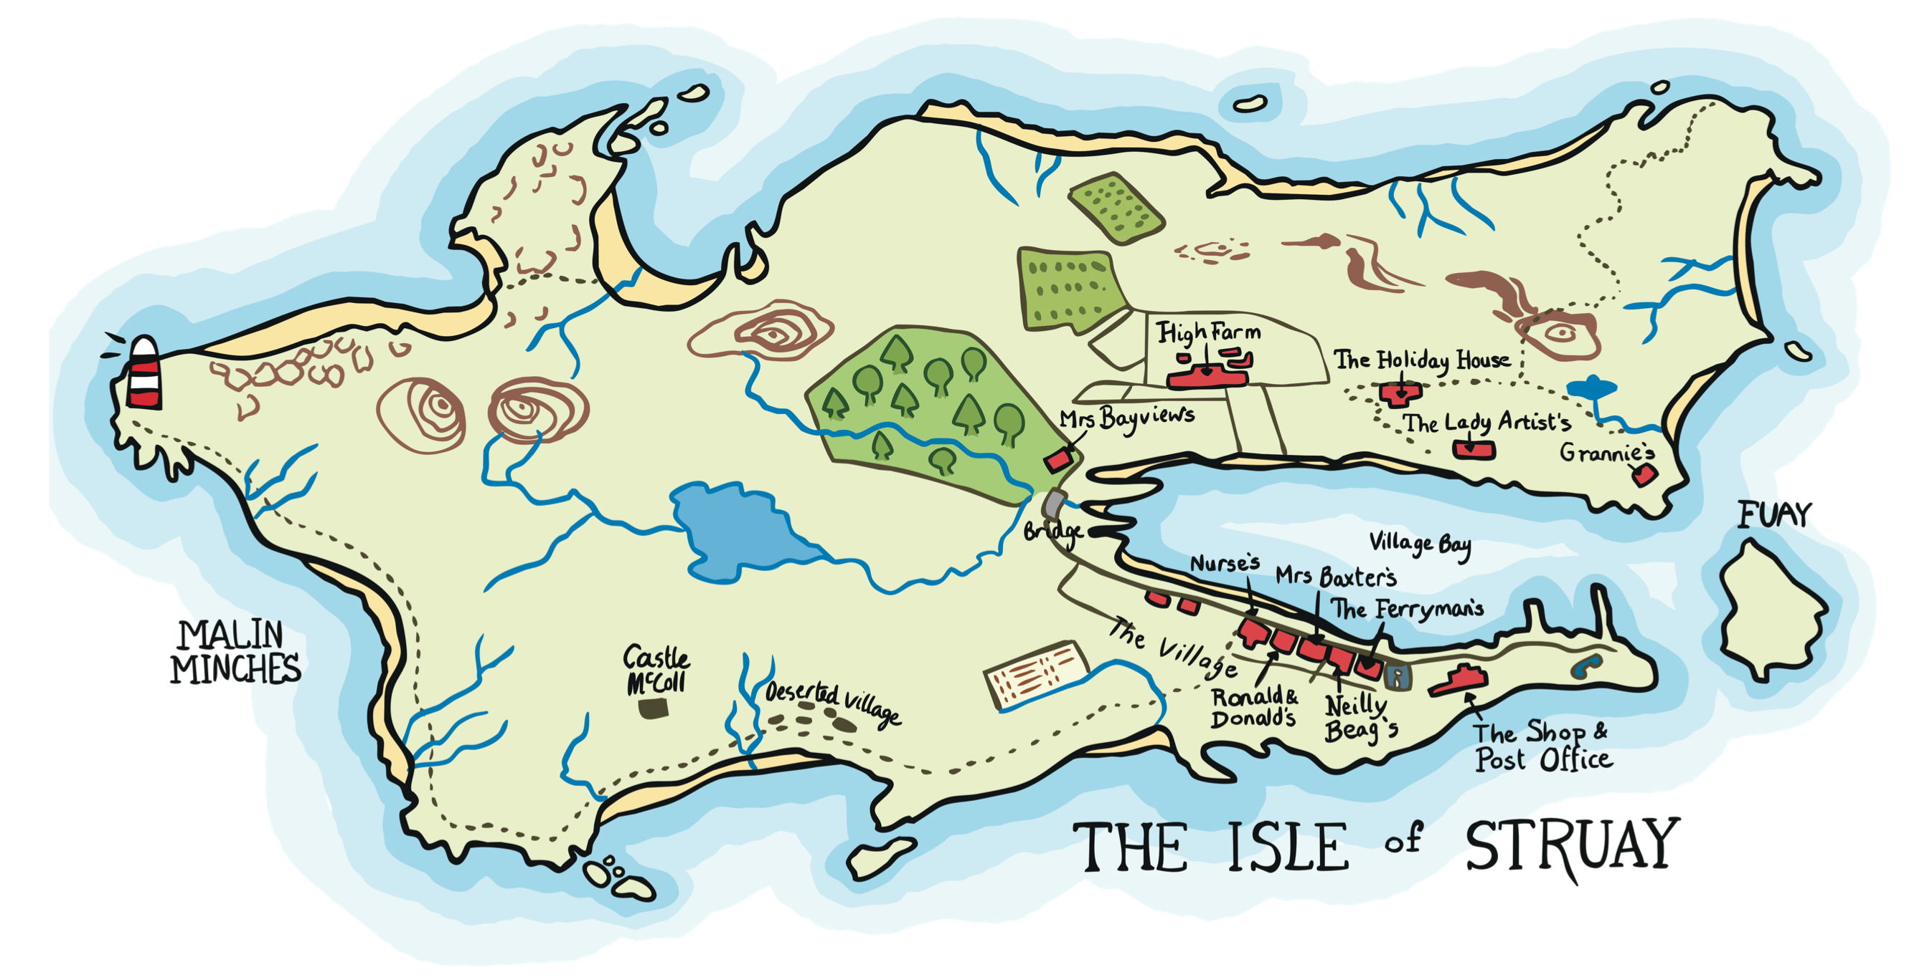
The Isle of Coll is in Scotland.
It belongs to a group of islands called the Hebrides.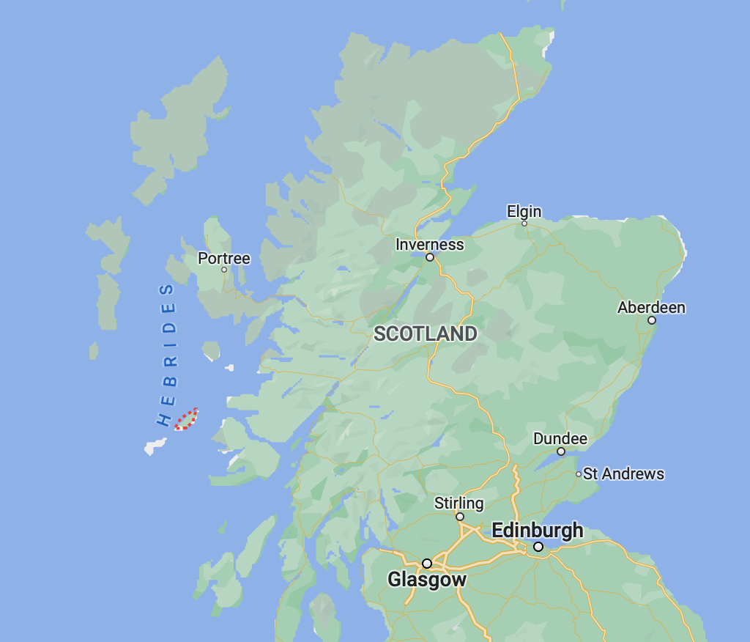
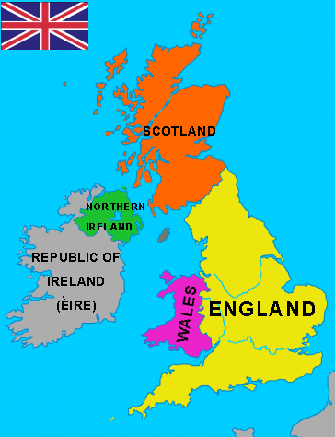
We live in the United Kingdom
which is made up of four countries:
England
Scotland
Wales
Northern Ireland

Isle of Coll

Year 1 sentence stems:  Where…  What…  How… | Working geographically This term we are working as geographers by:  -Using maps, atlases and globes  -Using aerial photographs  -Using fieldwork and observations | Year 2 sentence stems:  I know… because  I would…

