Key questions  - What is a seed, and what can it look like?  - Where do new seeds come from?  - How does a seed grow?  - Can I observe and describe the life cycle of a plant?  - Can I explain that humans use plants for food? | Key vocabulary  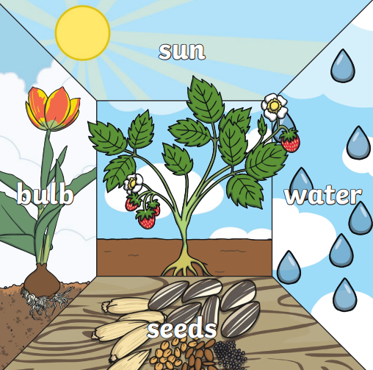  germination: when the conditions are right, the seed soaks up water and swells, and the tiny new plant bursts out of its shell. This is called germination.  grow: to get bigger  shoot: a shoot grows upwards from the seed or plant to find sunlight.  mature: a plant which is coming towards the end of its life cycle.
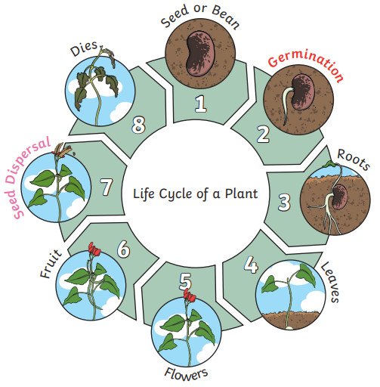
Key Knowledge
- Plants may grow from either seeds or bulbs.
- Plants also need different amounts of water, sunlight, the right temperature and nutrition to grow well.

