Key questions  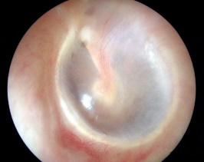  - Do I know how sound travels?  - Can I explain how my ears hear sound?  - Can I investigate pitch?  - Do I know what volume is and how it can be changed?  - Can I investigate sound and distance? | Key Vocabulary  ear drum: a thin flap of skin that is stretched tight like a drum and vibrate when a sound hits it.  energy: strength and power, which can come in many forms, including sound.  insulation: to cover something to stop energy passing through.  pitch: how high or low a sound is.  sound: something you can hear.  vacuum: a space without any air in it.  vibration: the rapid back-and-forth movement of physical particles, as a reaction to different forces.  volume: how loud or quiet a sound is.  waves: vibrations in which sound travels.
Key Knowledge
- A sound produces vibrations which travel through a medium from the source to our ears.
- Different mediums such as solids, liquids and gases can carry sound, but sound cannot travel through a vacuum (an area empty of matter).
- The vibrations cause parts of our body inside our ears to vibrate, allowing us to hear (sense) the sound.
- The loudness (volume) of the sound depends on the strength (size) of vibrations which decreases as they travel through the medium. Therefore, sounds decrease in volume as you move away from the source.
- A sound insulator is a material which blocks sound effectively.
- Pitch is the highness or lowness of a sound and is affected by features of objects producing the sounds.

